|  |  |  |  |  |  |
| --- | --- | --- | --- | --- | --- |
| Date | 9-Dec-22 | | | Tester Name | Mayuri Patel |
| Environment | Penfax - Test | | | Login used |  |
| Operating System | Windows | Version: | Update: | | |
| Software Used | Edge | Version: | Update: | | |
| Not Applicable | Version: | Update: | | |
| Release version | 22.4.1 | | | | |
| Title | External Transfer In | | | | |
| Test Type | Regression | | | | |
| Test Scenario | Process a transfer in from LIRA | | | | |
|  |  | | | | |
| Expected Results | Transfer In record should be available in Contribution History and Payroll History.  Transferred amount should be seen as a transaction record in Account Balances and Account Activity under Investments.  Member Deposit Letter should be generated in member’s account.  Contribution amount should be included in PEPP Valuation Report by employer name and the funds. | | | | |
| Pass/Fail | Pass | | | JIRA# | N/A |

Describe your steps with screenshots:

1. Bring up the active member in PENFAX5. Open up a member.

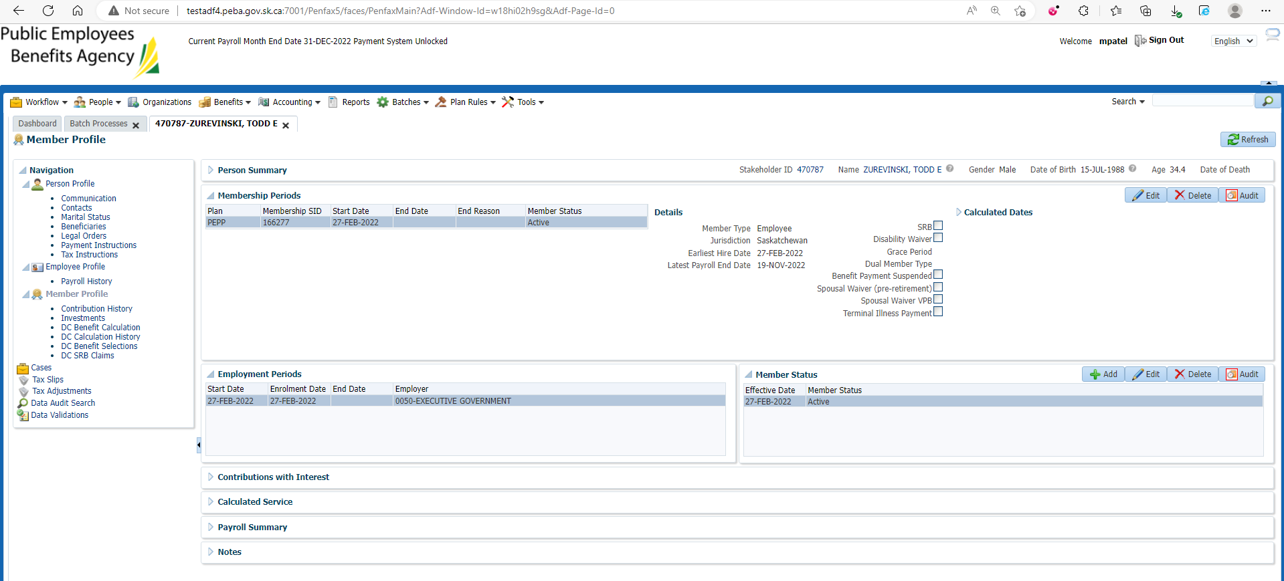

1. Log into DCT. Bring up the employer associated with the member in step 1. Click Create a new file.

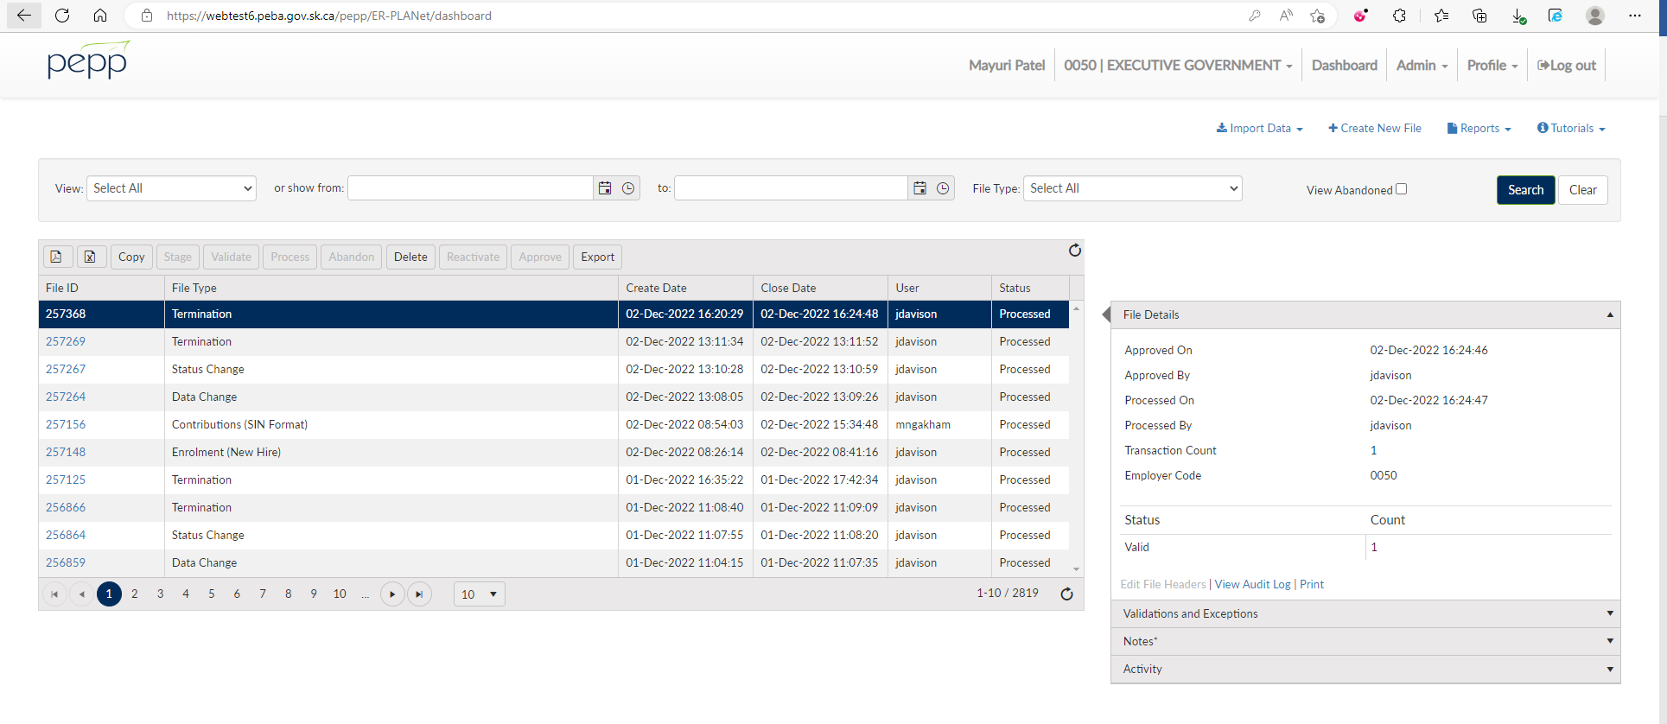

1. From the dropdown select External Transfer.

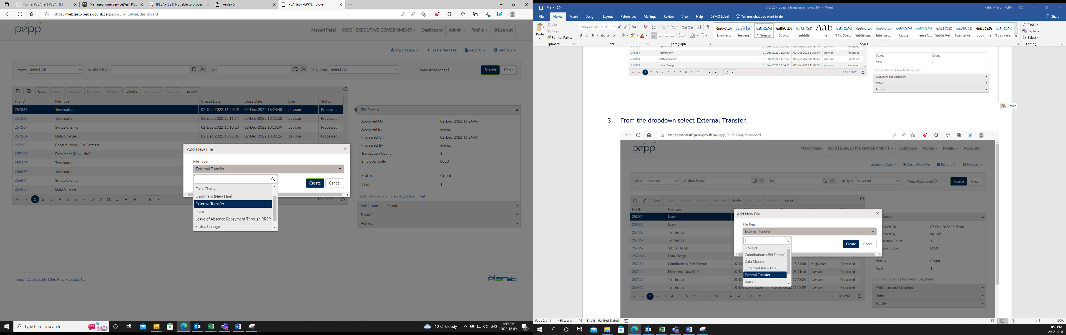

1. Click Create.

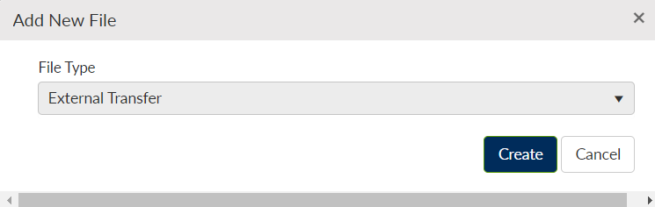

1. Click on File ID.

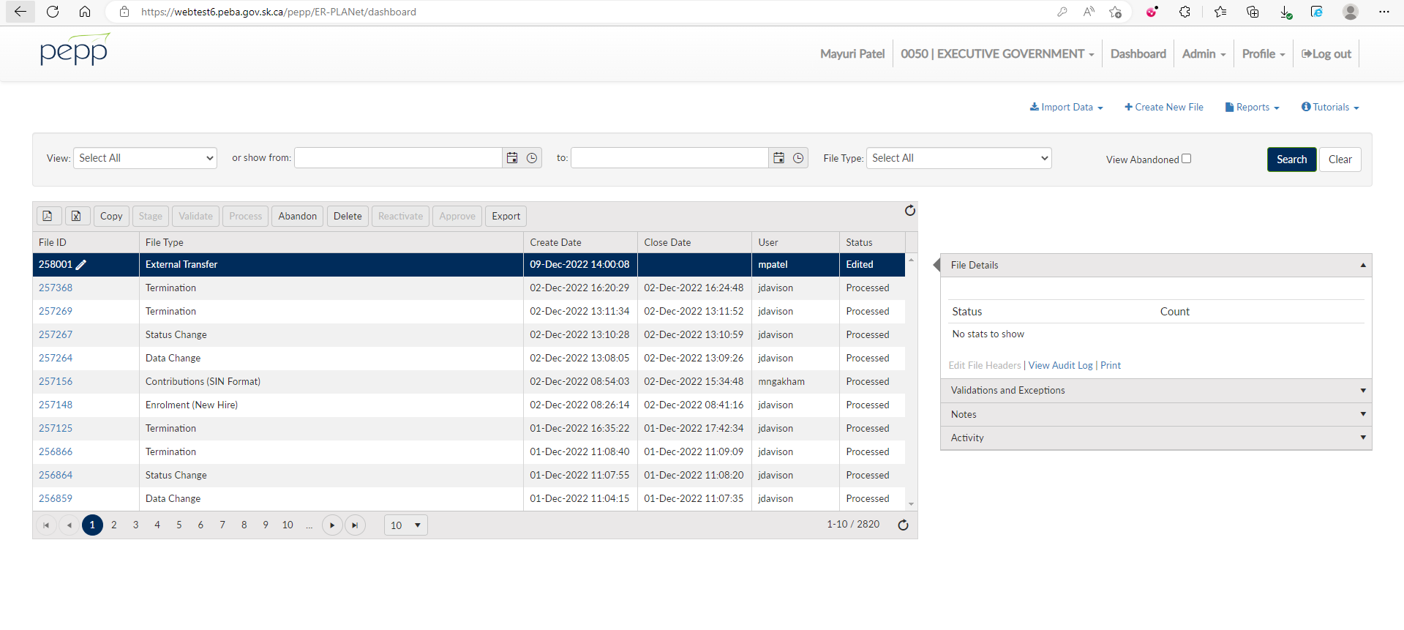

1. Click Add.

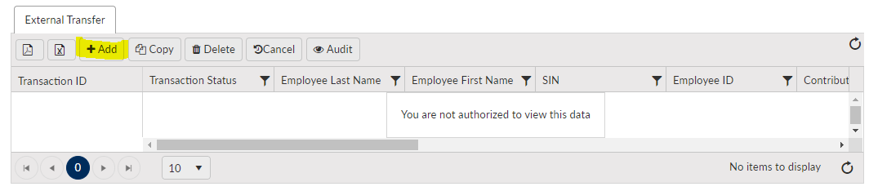

1. Input member’s information.

Under contribution source select LISK.

Under Locked-In Contributions enter an amount.

Leave Employee, Employer and Voluntary Contributions blank.

Enter an amount in Service purchased in years.

Input a service start date and service end date (has to be while working with this employer).

Under Transfer type select LIRA.

Click Save.

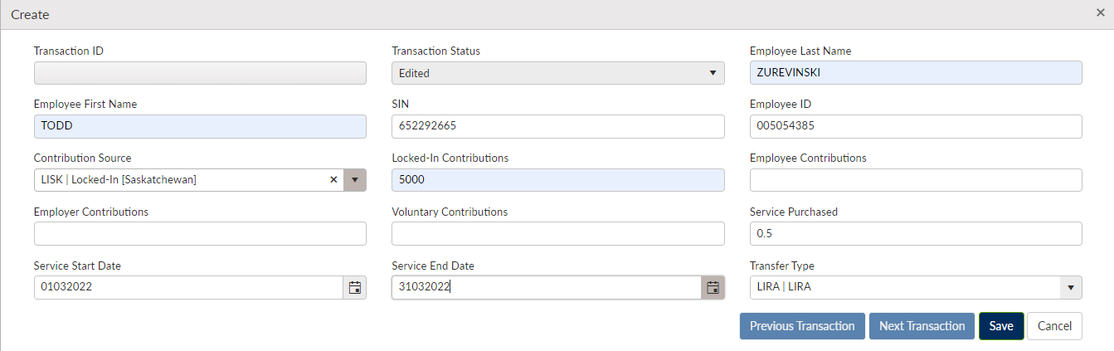

1. Under File Details Validate, Approve and Process the file.

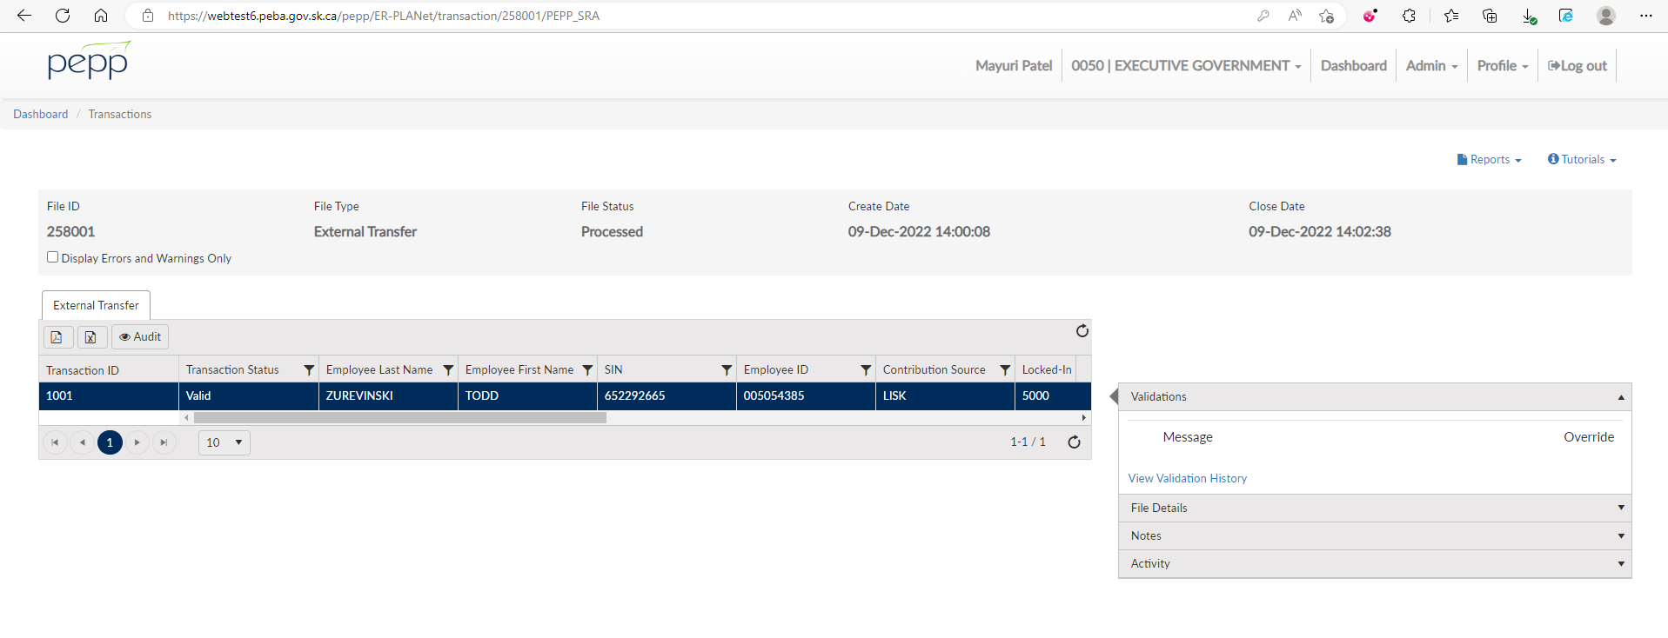

1. Go back to PENFAX5.

Go to Batches, then Data Posting Batches.

Search for the file you just uploaded.

Click on the Data Posting Batch ID.

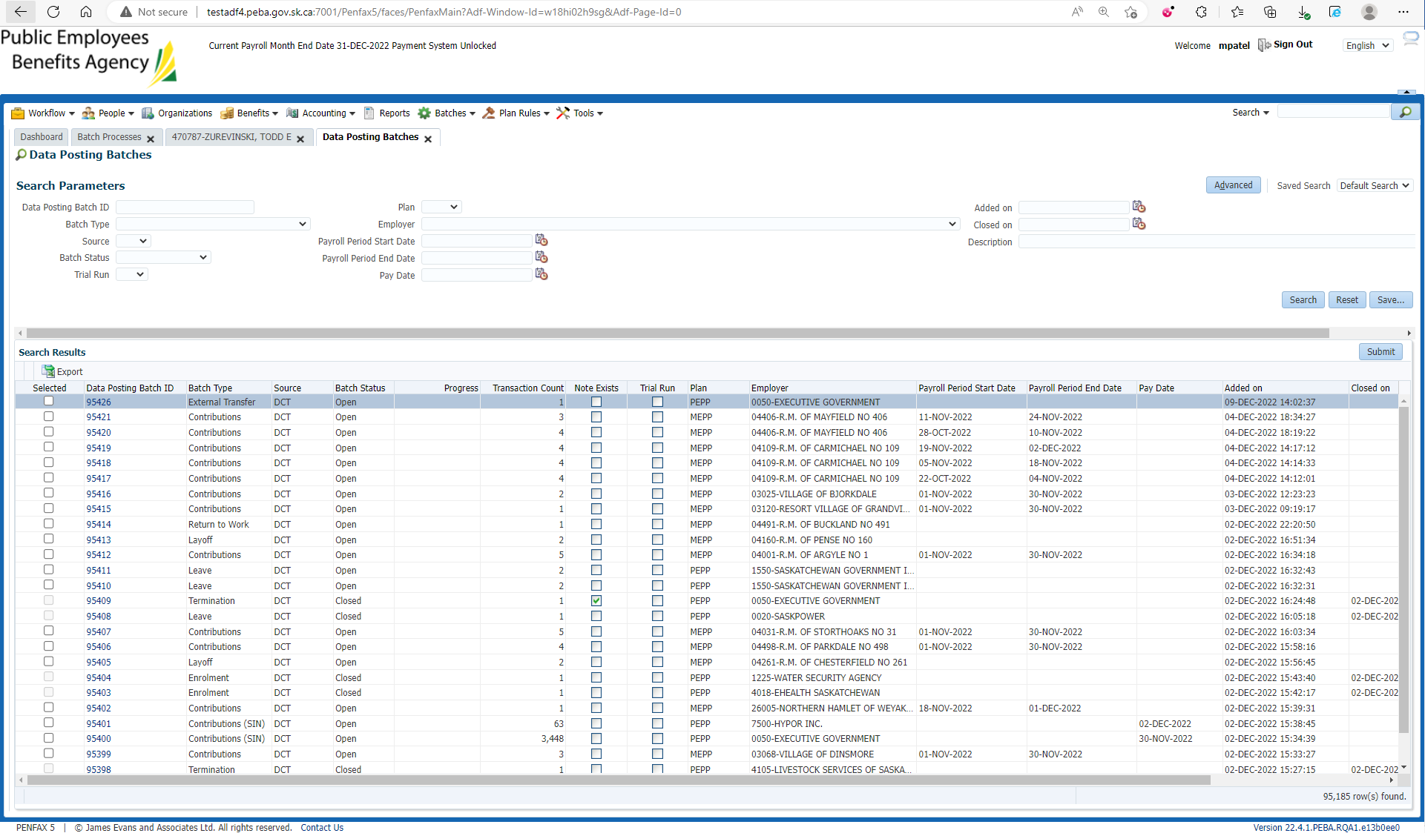

1. Click on the Pending Tab.

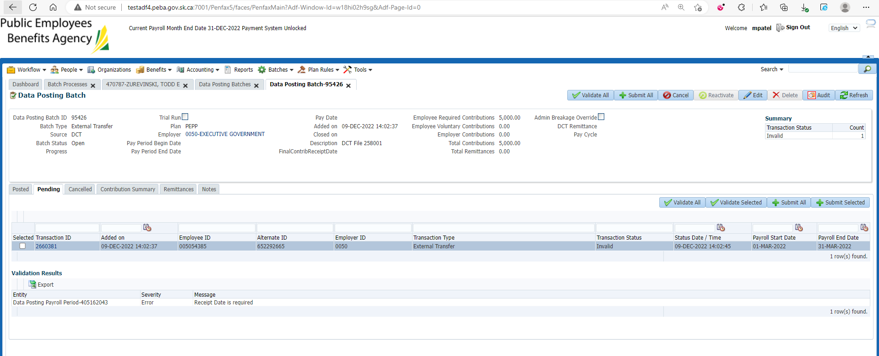

1. Go to Remittances tab. Click Add and link a remittance.

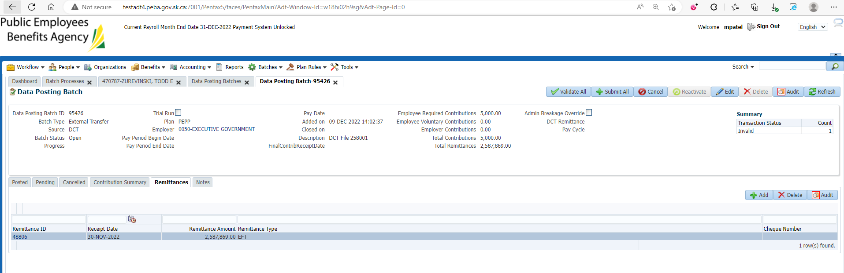

1. Then go to Pending tab. Click Validate All and that error for Receipt Date has will be gone.

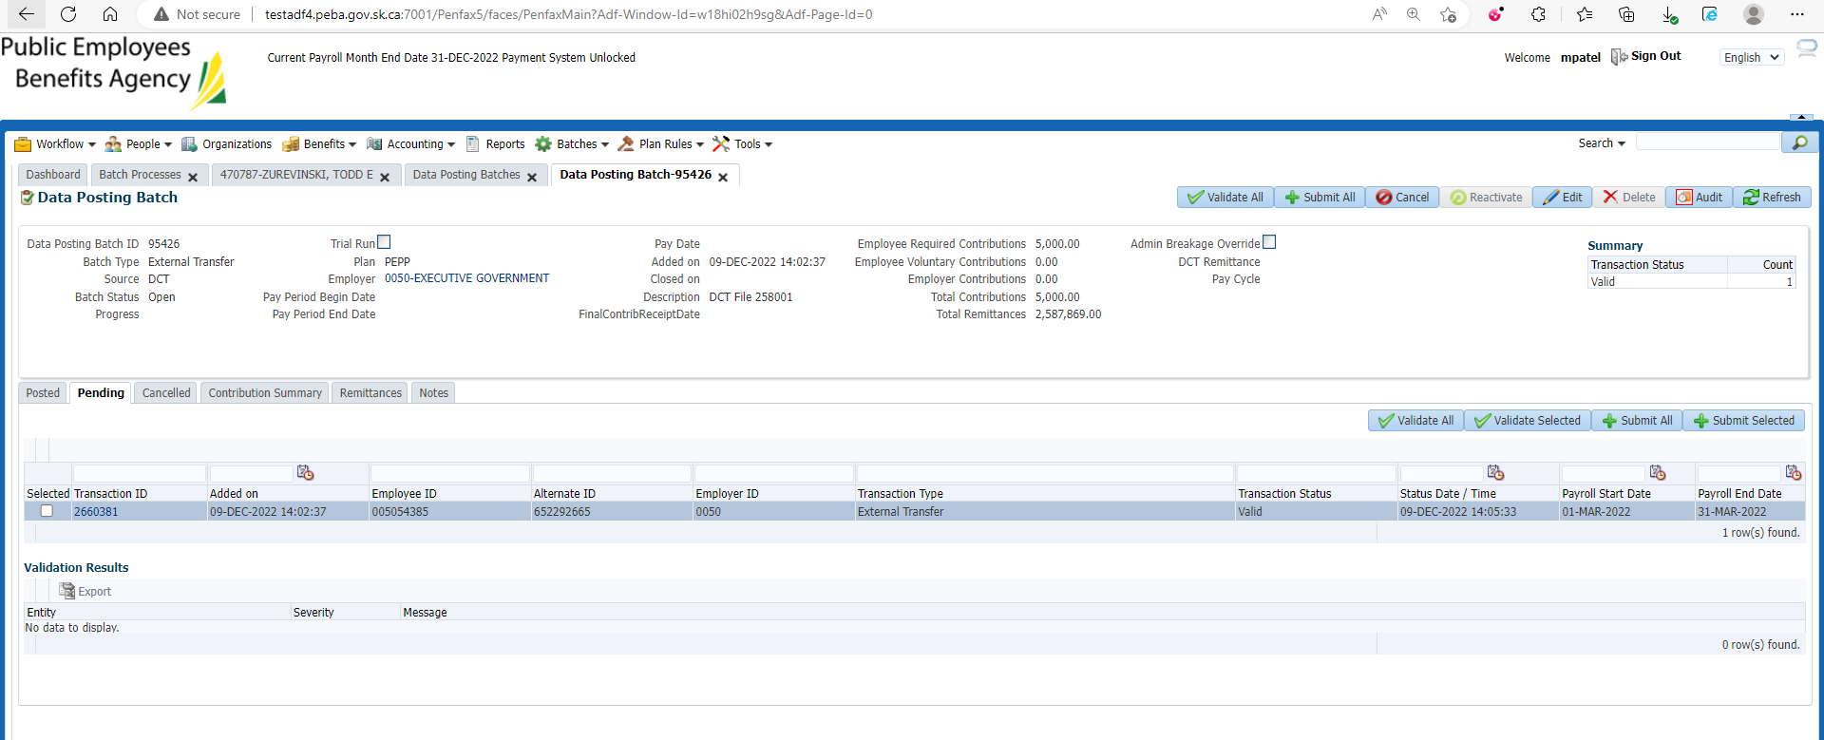

1. Click Edit and enter PEPP Receipt Date and Save.
2. Now, validate and submit the data posting batch.

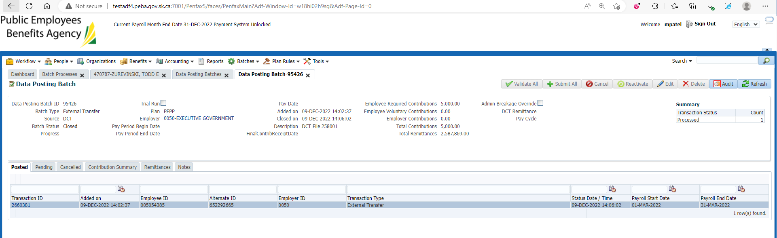

1. Bring up the member in PENFAX5. Go to the Member Profile -> Contribution History. The transfer should show up there.

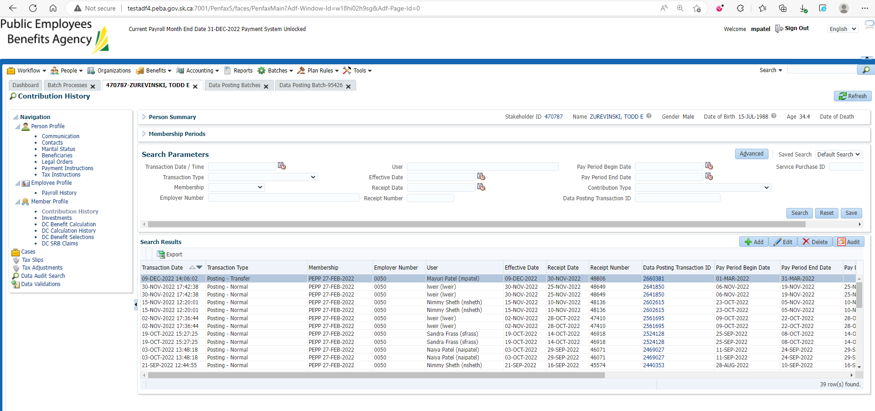

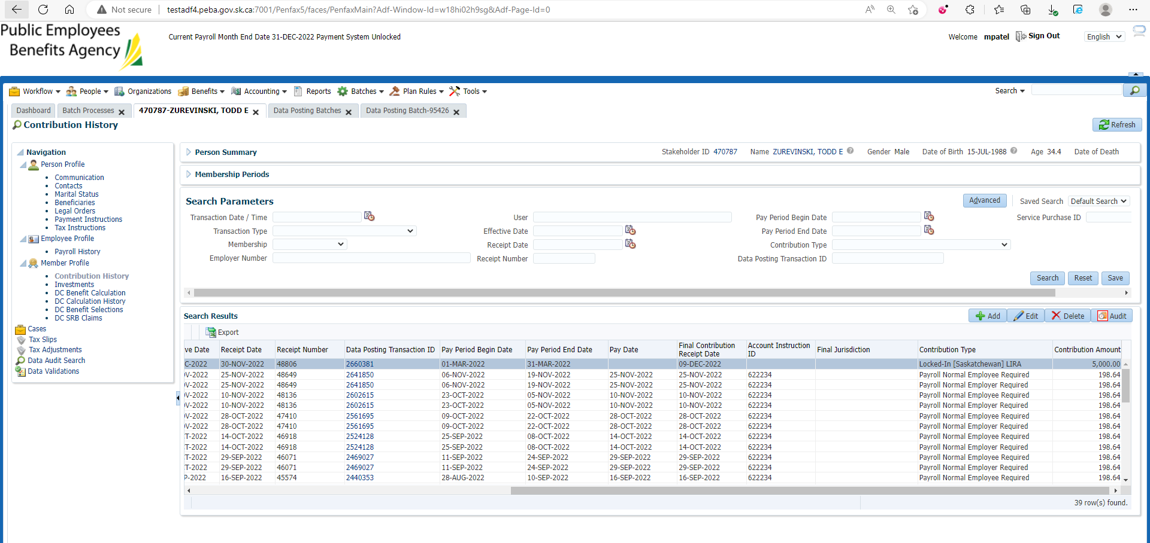

1. PIT batch runs overnight.
2. Go to the Member Profile -> Payroll History. Under Payroll History the new transfer should be included in the totals.

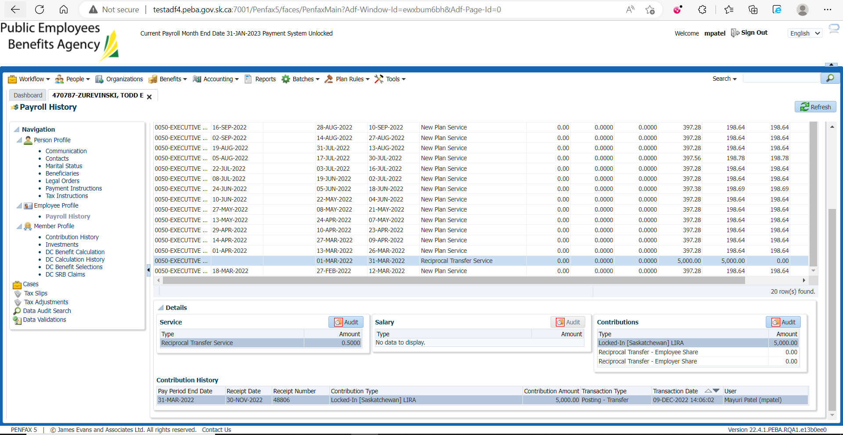

1. Go to the Investments Tab. Make sure the money shows up in the balance of the account.

Also check the Deposit Allocation. Make sure the funds went into the correct account.

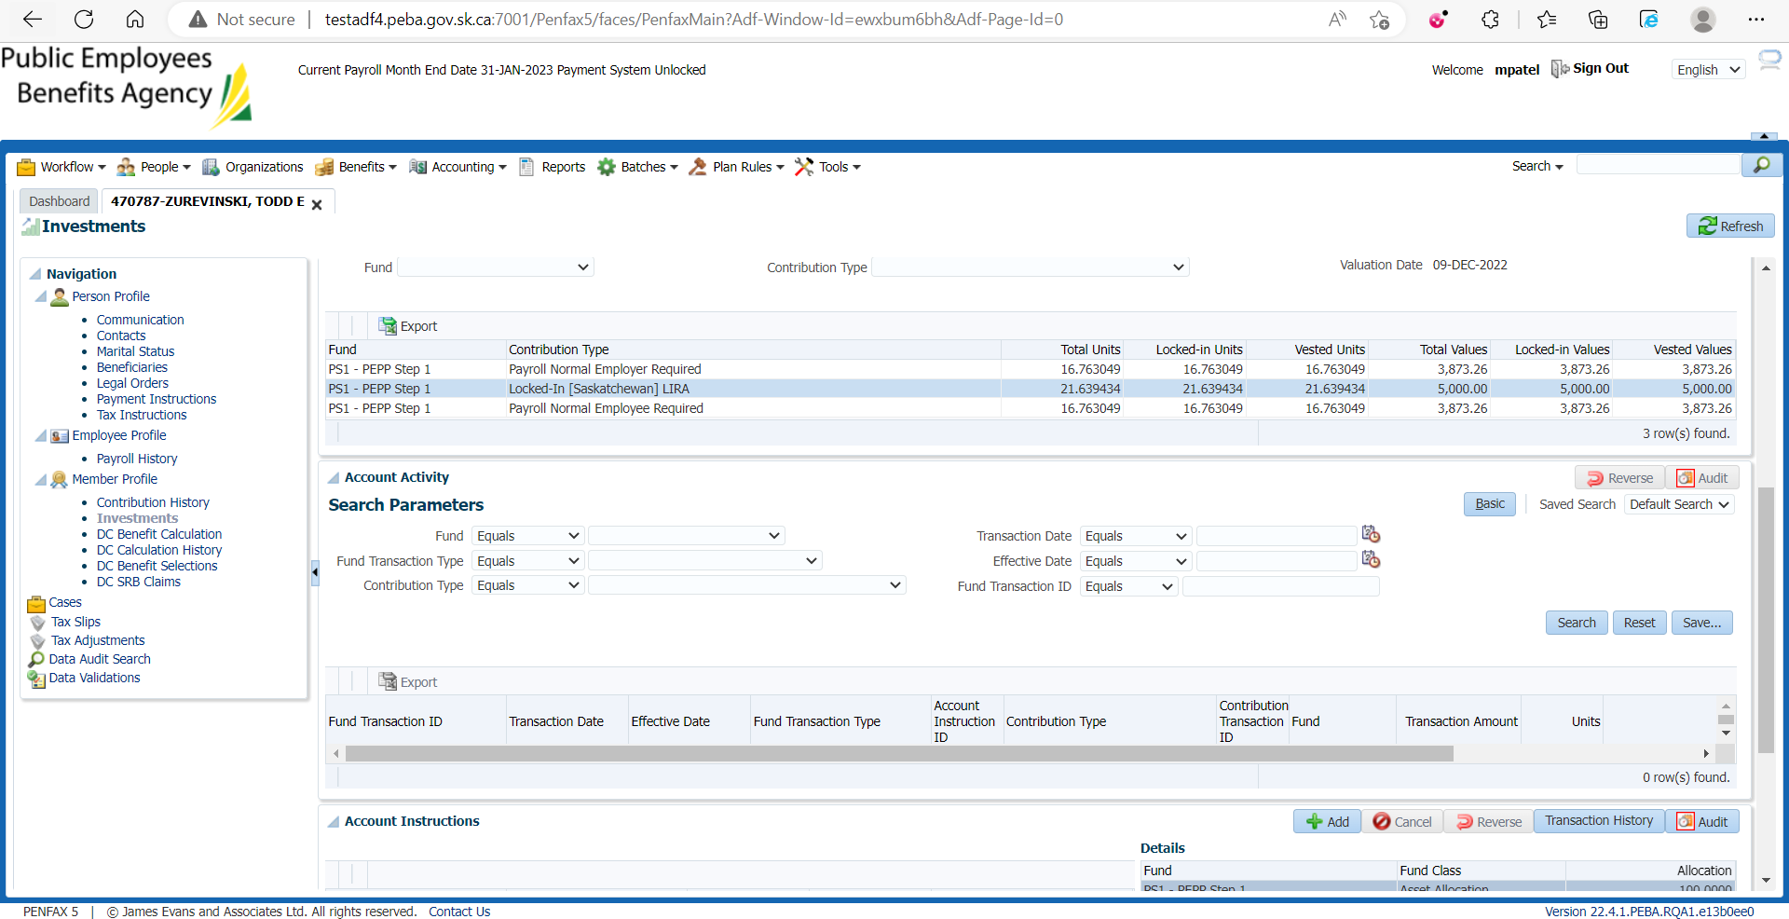

1. If you do a search under account activity it should show the transaction.

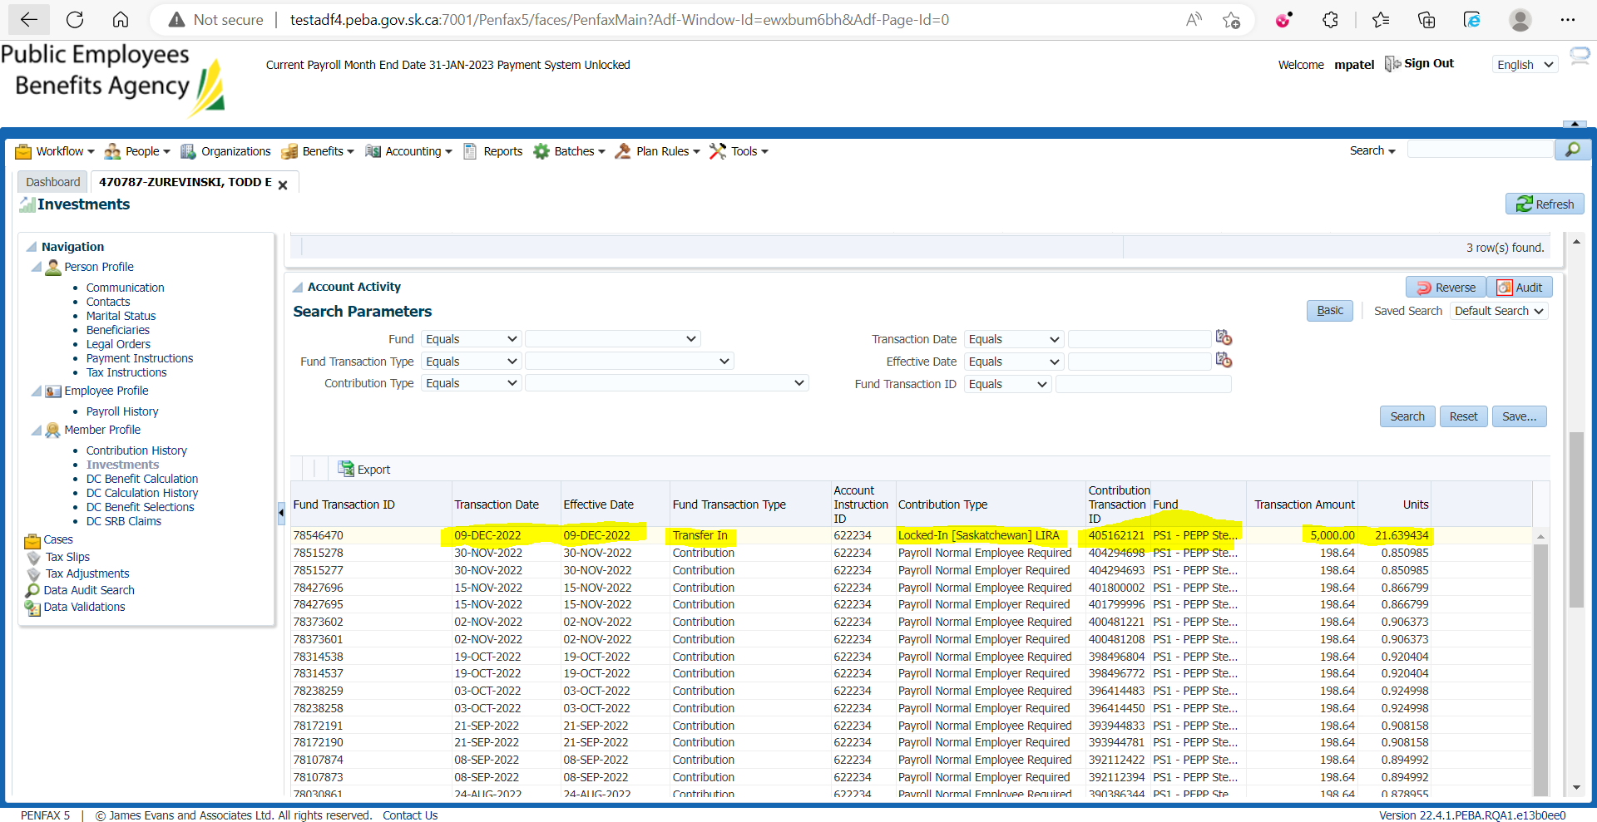

1. Go to the Communication tab. There should be a member deposit letter saved under Outbound Documents.

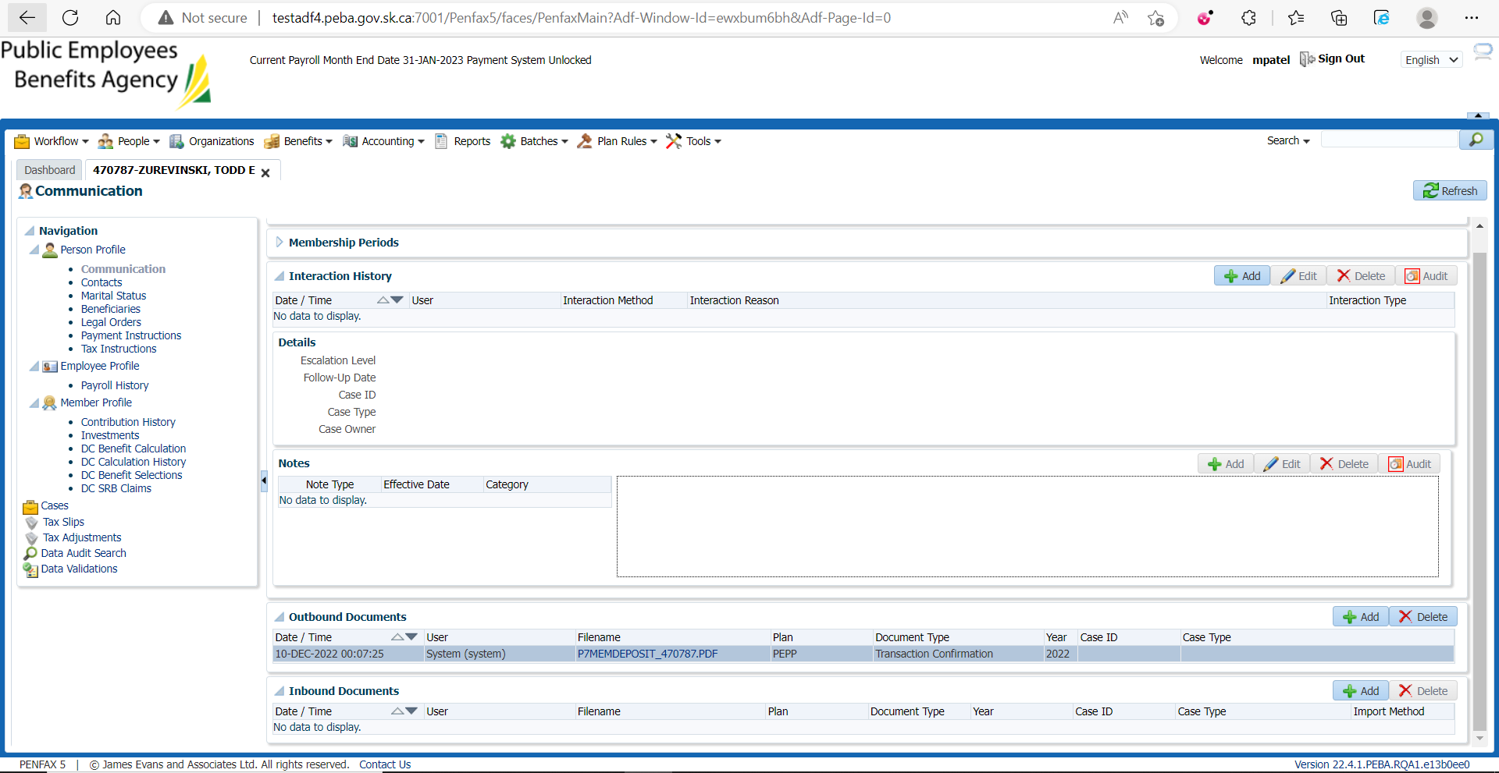

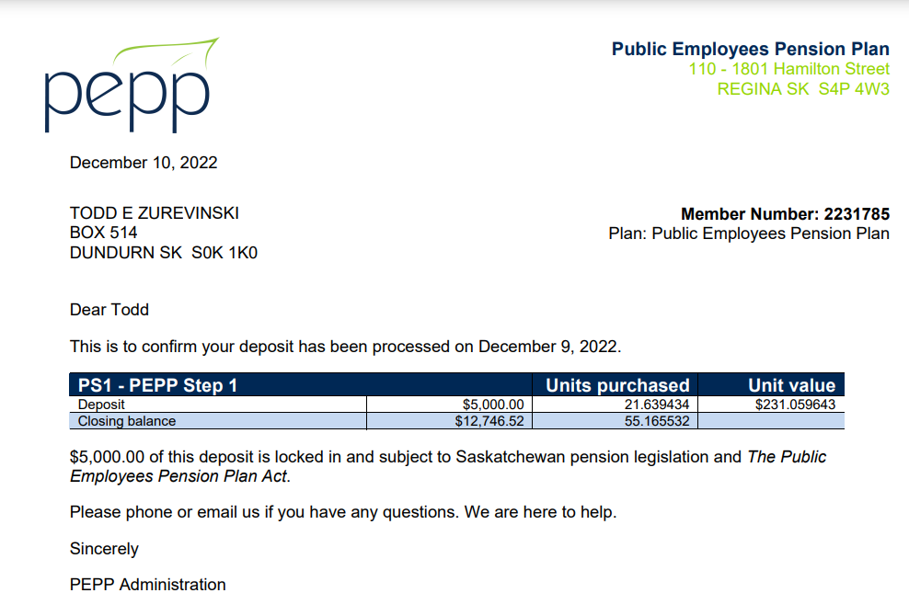

1. Go to Batches -> Batch Processes. Search for PEPP Valuation Report and open the first one.

For SID: 470787, $5000 transferred into PS1 under the employer Executive Government that can be seen on Section Two tab.

